CSCE 606 - Vaccine Hesitancy Game: Iteration 2

**Team roles:**

* Scrum Master: Catherine Shen
* Product Owner: Benjamin Hawn
* Team Member: Liuyi Jin
* Team Member: Bhogesh Maddirala

**Github repo:** <https://github.com/bhawn/CSCE_606_Project>

**Pivotal Tracker:** <https://www.pivotaltracker.com/n/projects/2536278>

**Deployment:** <https://powerful-sierra-98545.herokuapp.com>

* Not on github pages due to copyrighted music/sounds will update soon. Used a fake back-end for heroku.

**Customer Meeting Dates:**

* + Demo displayed player and enemy virus entities with the player shooting
* (11/16/21) Showed a short video demo of the game to Dr. Walker. The hypodermic needles shoot at viruses as they converge onto the player, along with player movement and how covid cells attack you. Sample background music and attack audio was also included.
  + Discussed feedback on demo about improvements and next steps. Priority is to have basic game mechanics working--player shoots and kills viruses to achieve high score until player’s HP bar is depleted, player can pick up vaccine item drops to increase the amount of ammo it shoots, randomize virus spawn locations, have background and sound related to theme--then focus on browser and mobile compatibilities.
  + Dr. Walker will share the video clip demo with VetMed faculty.

**User Stories :**

* **Completed with Low-fi UI**:
  + Write iteration report 2
  + Feature: Player Entity Movement

As a Player

I want to move my character.

So I can explore or dodge enemies in the game.

| **Design** | **Implemented** |
| --- | --- |
|  | (It’s moving, trust me) |

* + Feature: Create Enemy Entity

As a Player

I want to encounter enemies (viruses)

So that I can attack or run away from them.

| **Design** | **Implemented** |
| --- | --- |
|  |  |

* + Feature: Enemy Entity Movement

As a Player

I want enemies to move towards me

So that there is something I need to overcome to win.

| **Design** | **Implemented** |
| --- | --- |
|  | (Again, there is movement) |

* + Feature: Create Attack Methods

As a Player

I want to shoot antibodies/tcells/etc at viruses

So that I can attack and destroy them.

| **Design** | **Implemented** |
| --- | --- |
|  |  |

* **Current** User Stories with low-fi UI:
  + Feature: Entity Collision (pick up drop, damage, etc)

As a Player

I want to interact with other entities

So that I can interact with different parts of the game.

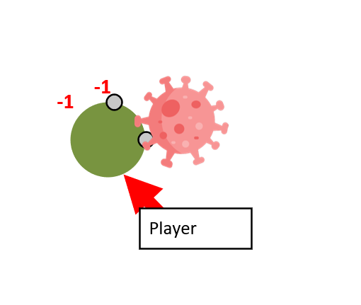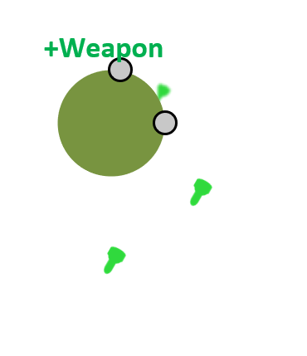

* + Feature: Create Drop entities

As a Player

I want to encounter drops (vaccines, spike proteins)

So I can improve my attacks.

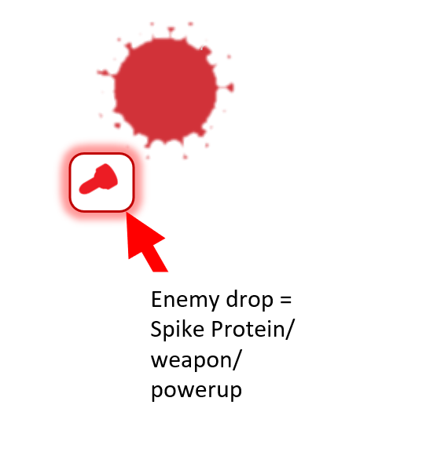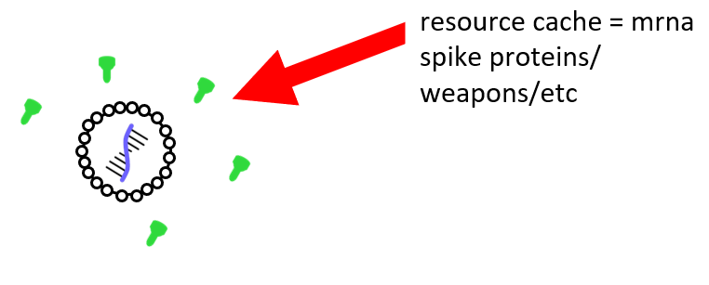

* + Feature: Create player HP mechanic

As Player

I want an HP mechanic

So that I can see how close I am to failing

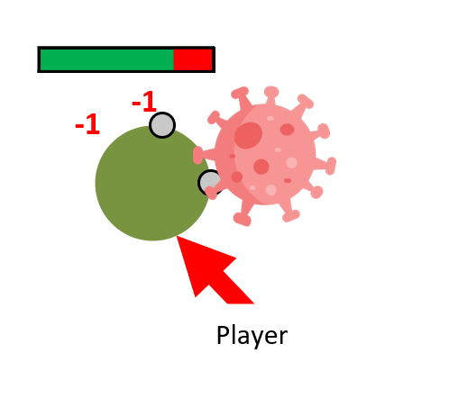

* + Feature: Increase amount of ammo player can shoot on vaccine drop pickup

As a Player

I want more ammo

So that I can keep using the same weapon

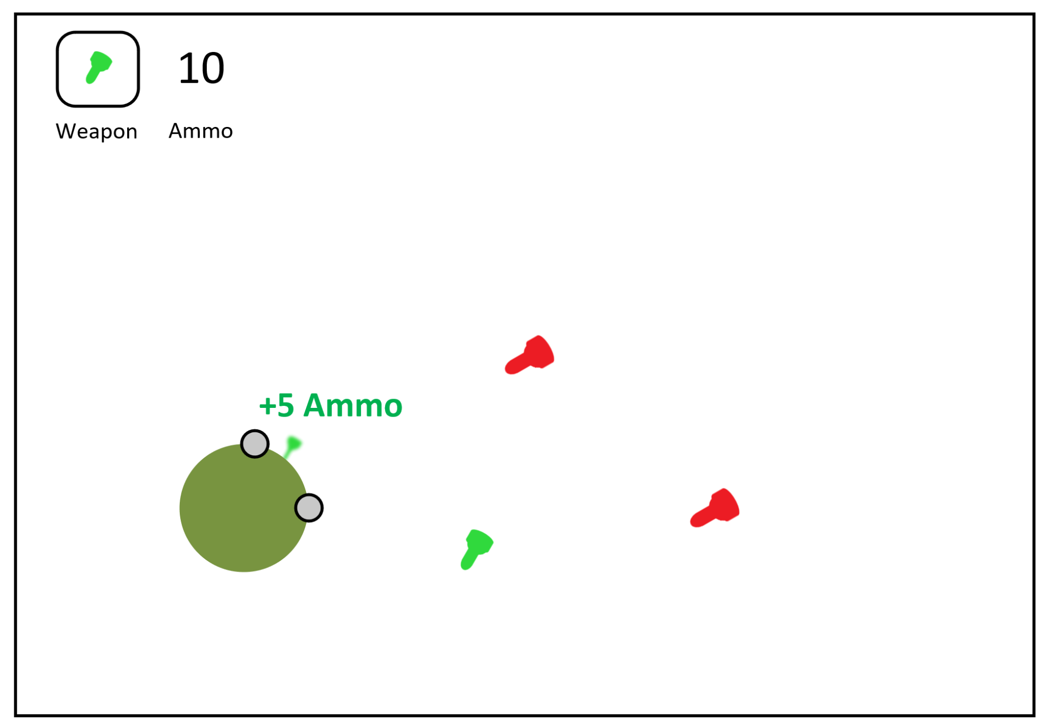

* + Feature: Enemy Spawn Progression

As a Player

I want harder and more enemies as I progress

So that I can feel accomplished if I win.

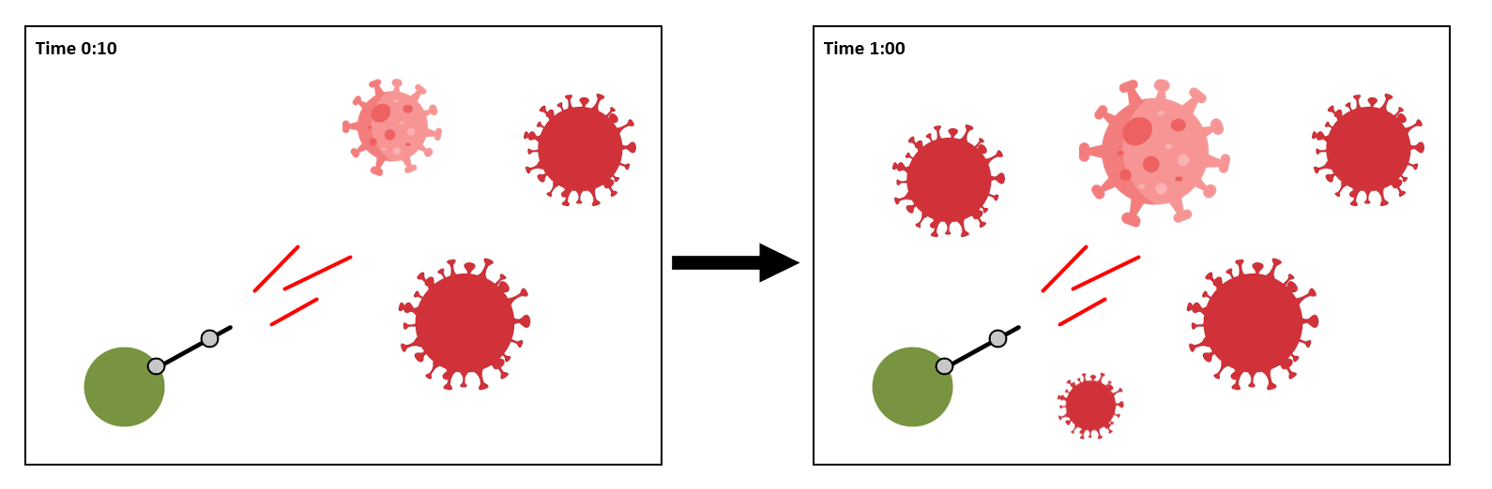

* + Feature: Score

As a Player

I want to see a game score

So I can see how well I'm doing and compare with friends.

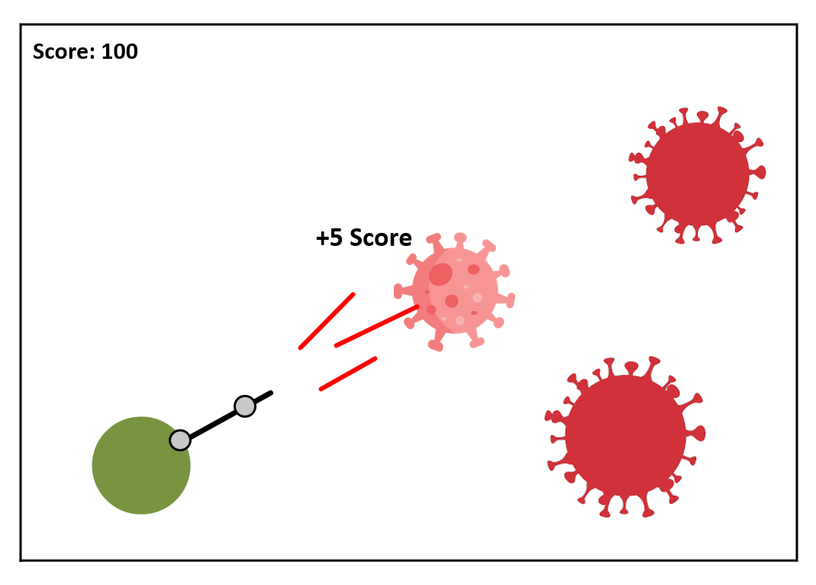

* + Feature: Death and/or Respawn

As a Player

I want there to be a consequence in failing

So that I can feel accomplished in winning

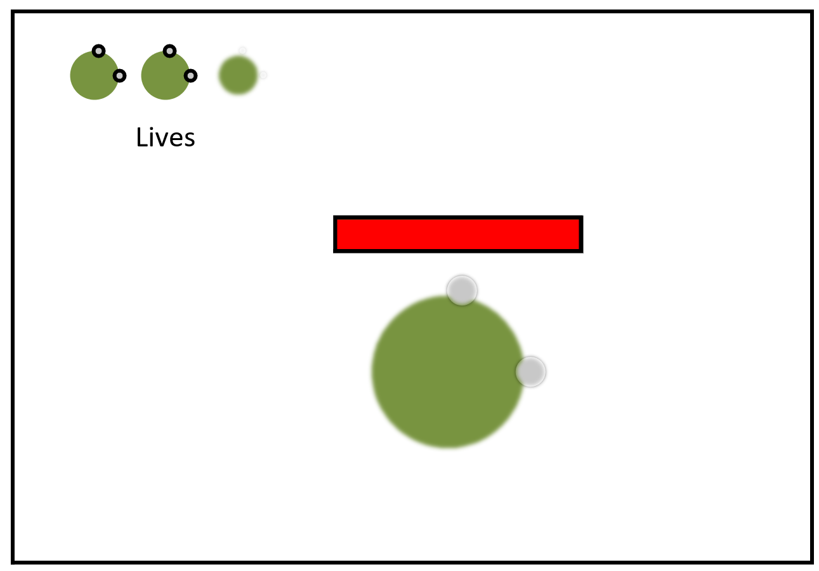

* + Feature: Weapon Variety

As a Player

I want there to be multiple weapons

So that there is variety in the game

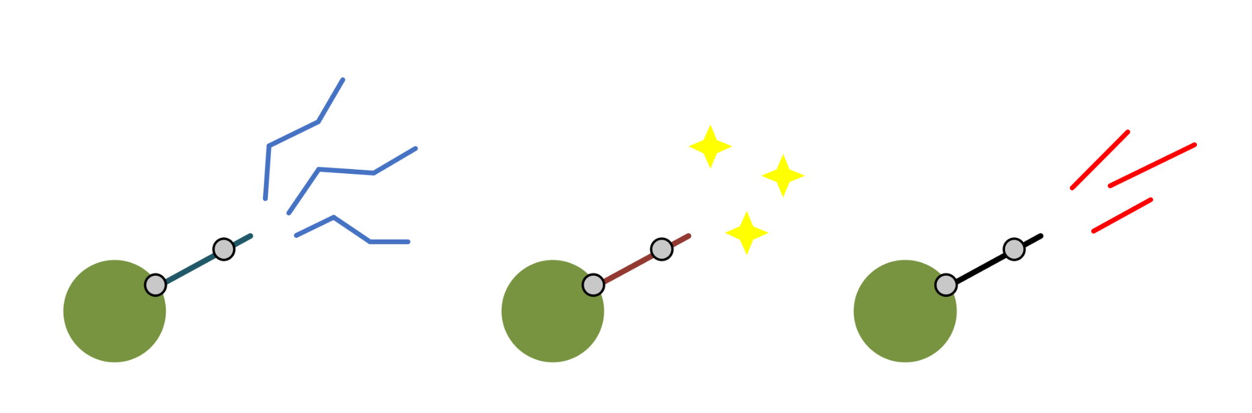

* + Feature: Game and Phaser framework documentation

As a developer

I want to document how the game works

So that in the future, developers can improve the game

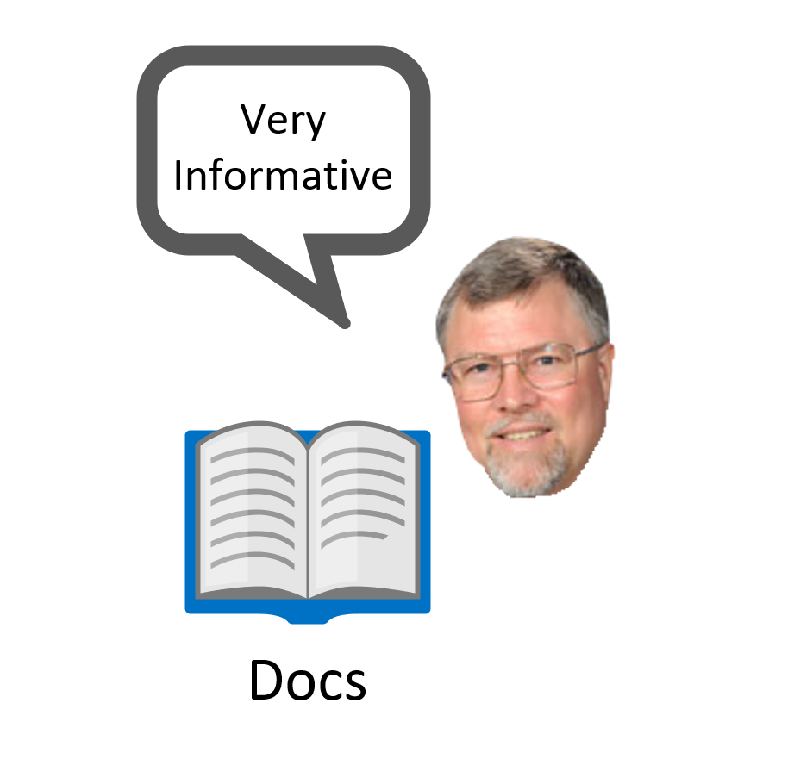

* + Feature: (Low Priority) Loading/Credits Screen

As a developer

I want there to be a loading/credits screen

So that I can load assets or let people know that I worked on this.

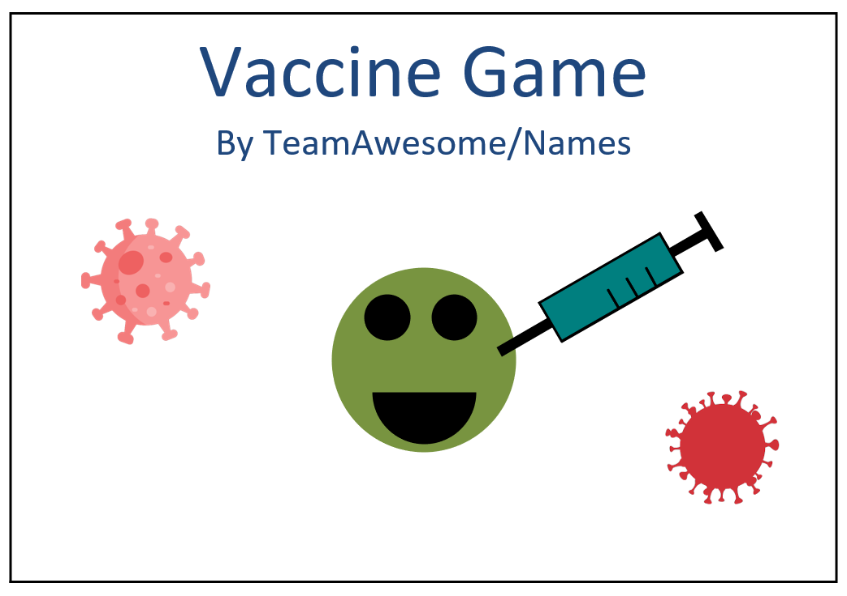

* + Feature: (Low Priority) Main Menu Screen

As a Player

I want a Main Menu Screen

So that I can play the game when I choose

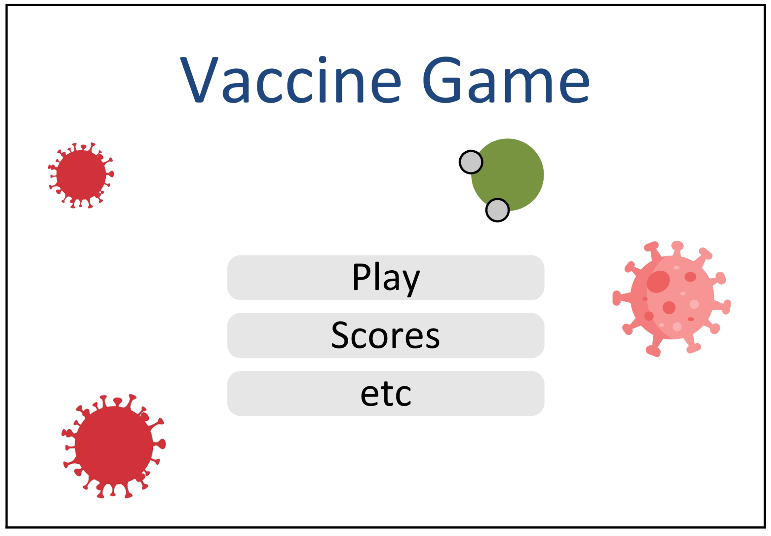

* + Feature: (Low Priority) In Game Instructions (e.g. WASD to move/Defeat the viruses!)

As a Player

I need instructions

So I know how and why to play.

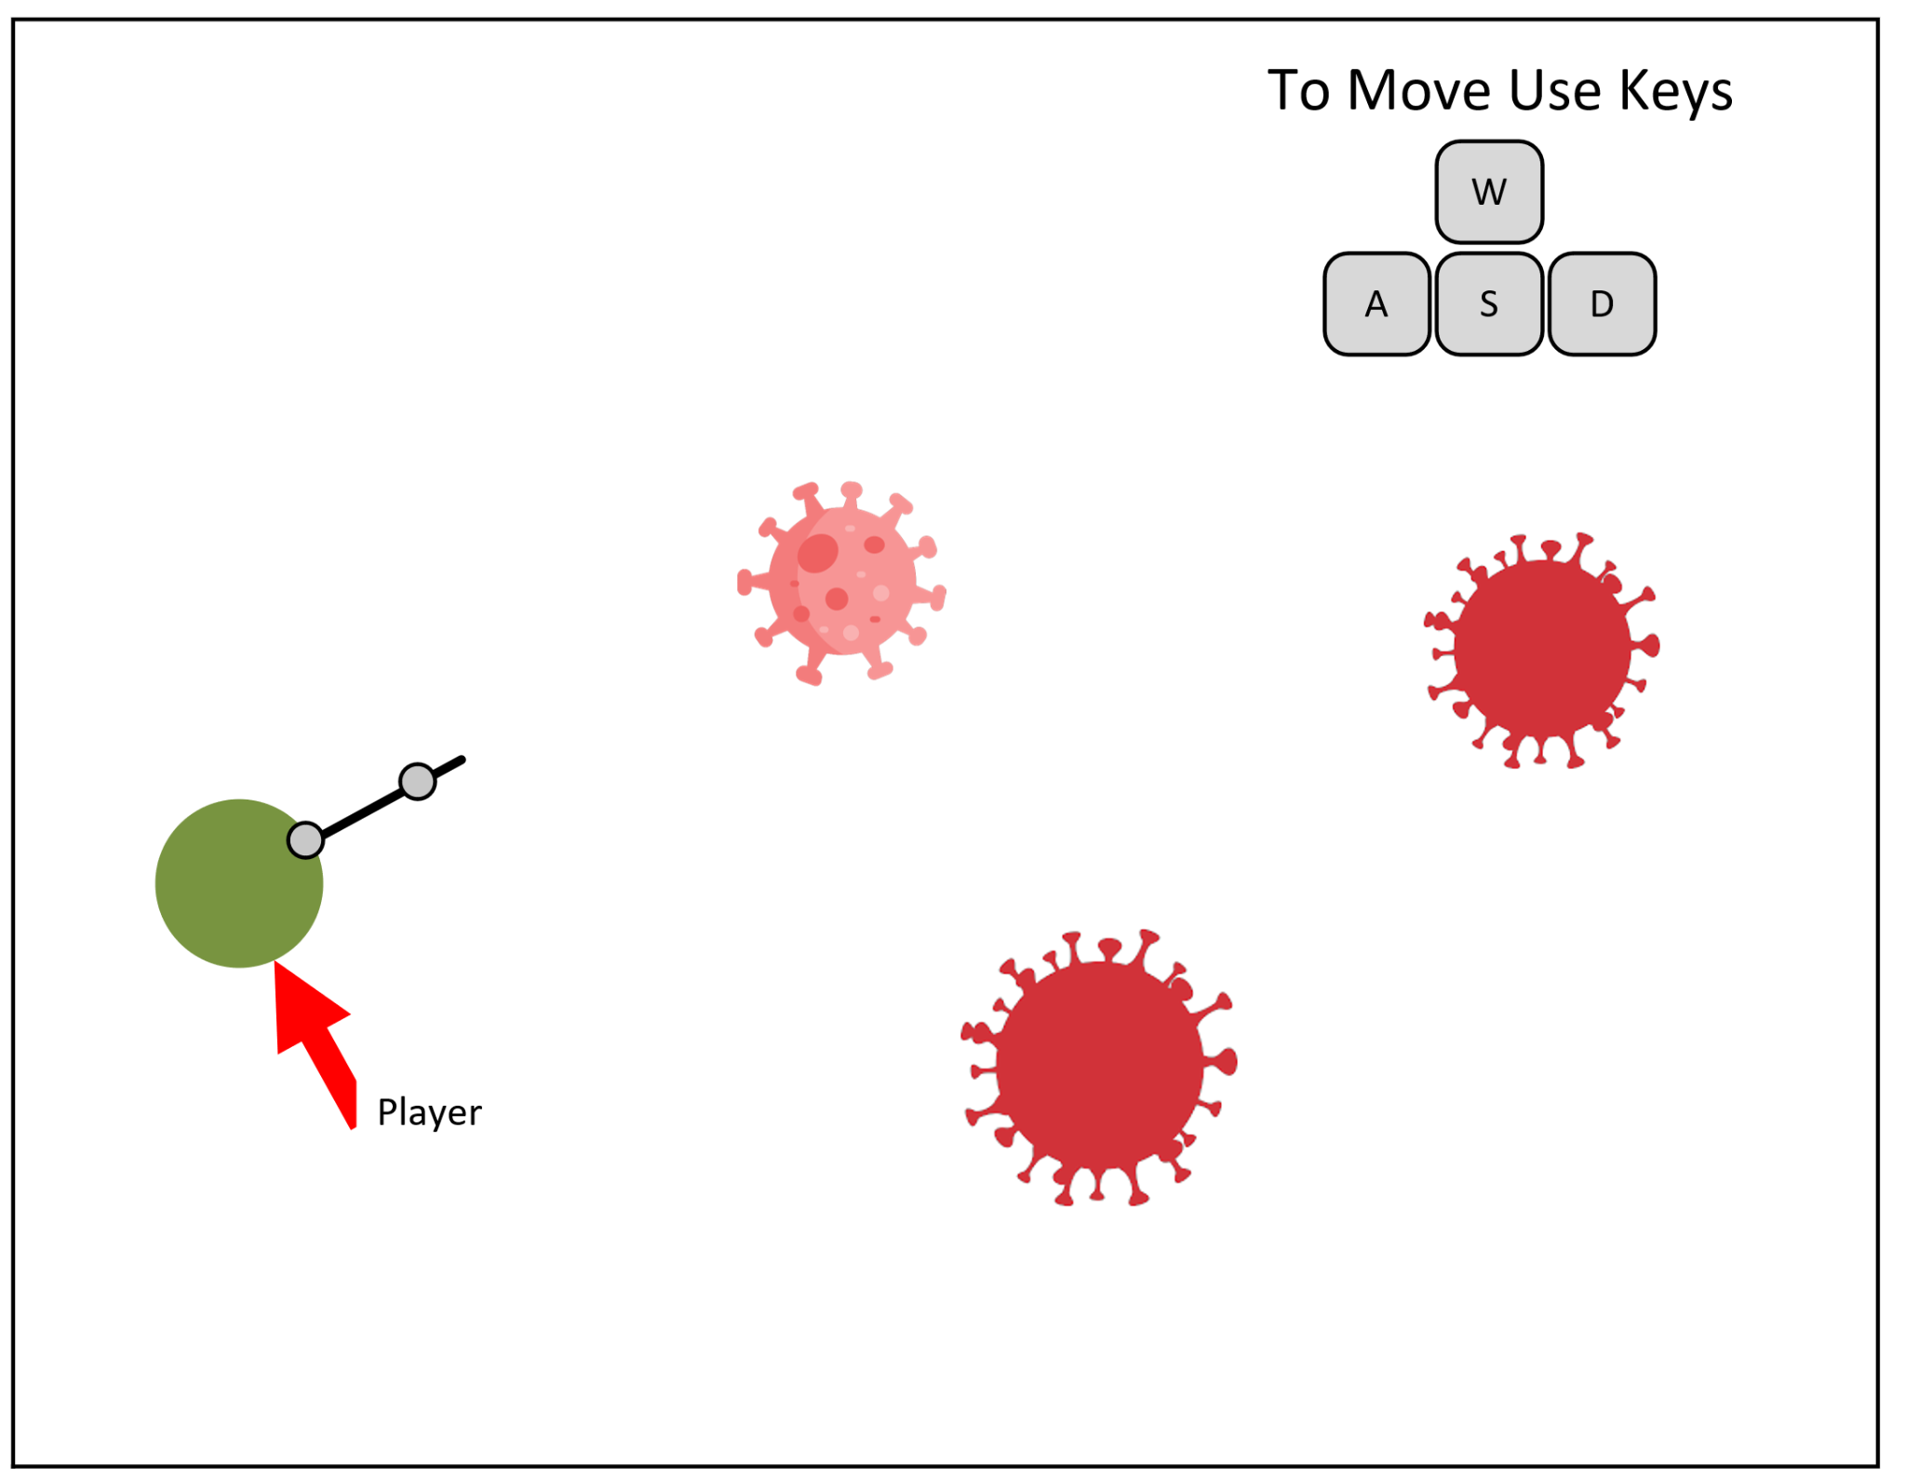

* + Feature: (Low Priority) Browser compatibility

As a user of a old phone model

I want the game to work

So I can play it

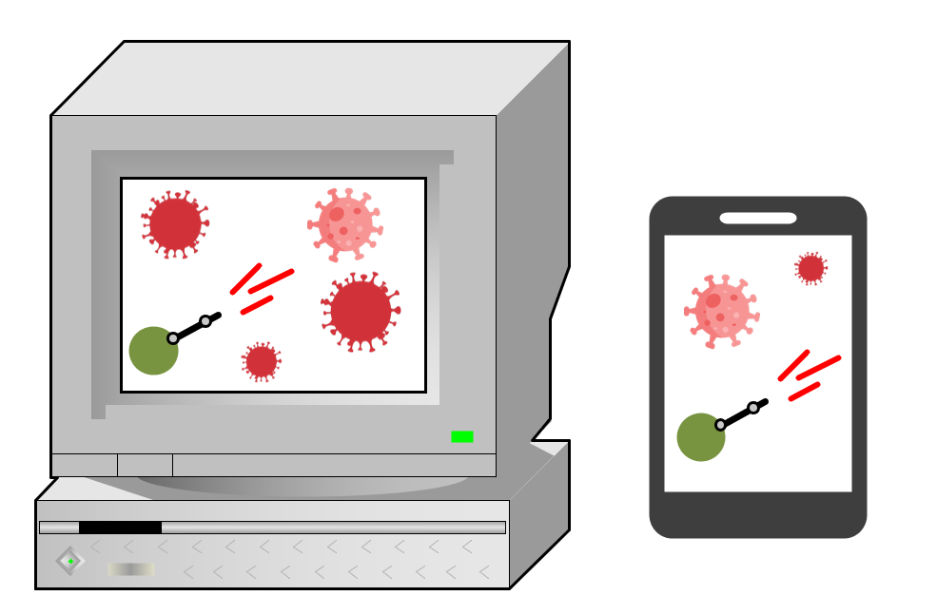

* + Feature: (Low Priority) Shader Effects (Lights, particles on bullet hit, etc..)

As a player

I want the game to have ƒancy effects

So that the game looks nice

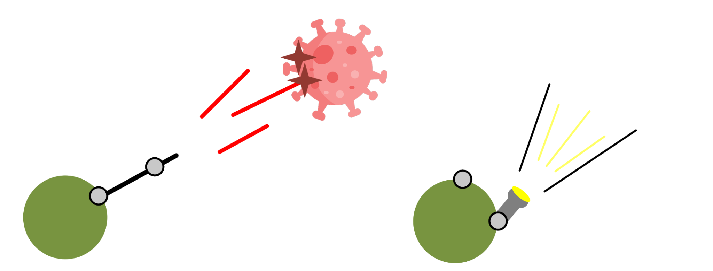

**Design Diagram:**

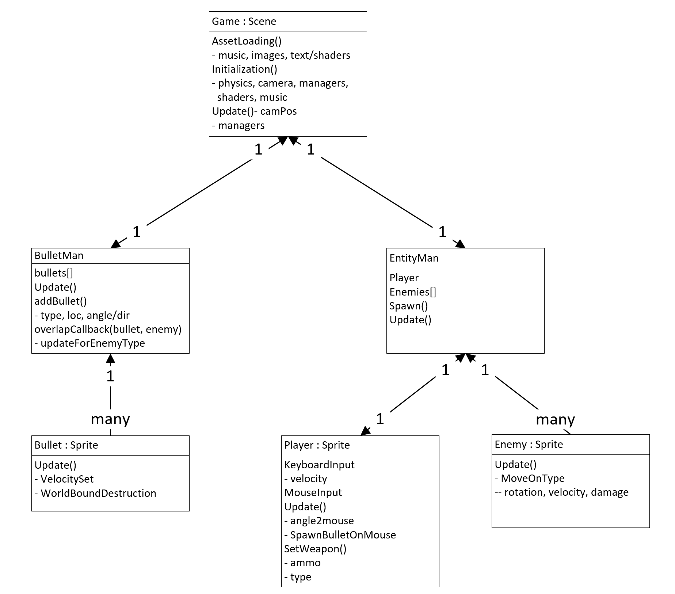

**StoryBoard:**

* Added the new game mockups to the storyboard and removed the improper user stories from it, since they were more end goals rather than implementable stories at each iteration.

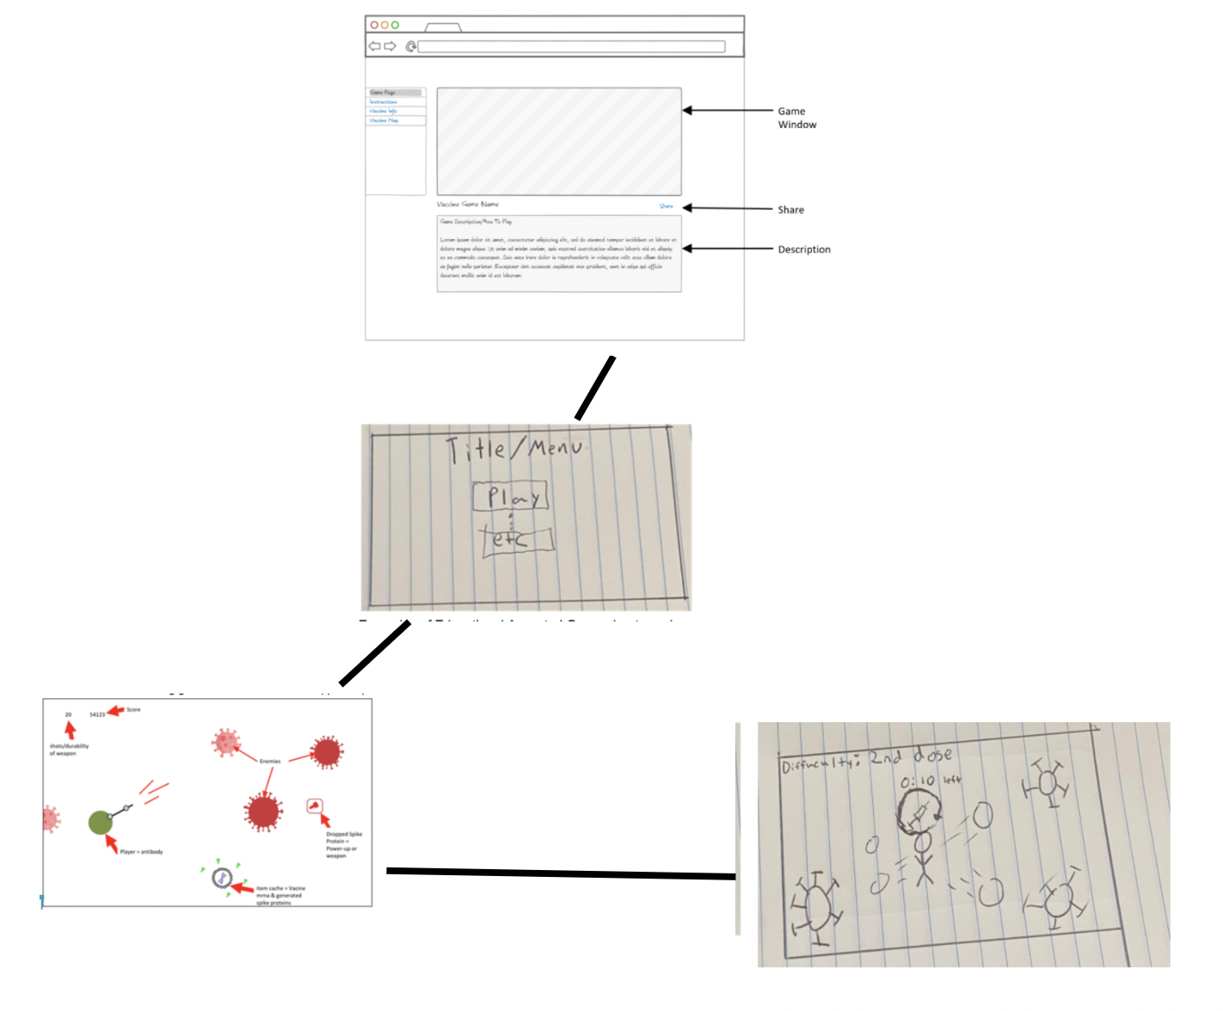

**Incomplete User Stories:**

If you were not able to implement all the stories that you initially chose for this iteration, please list which ones and why not.

* Item Drops:
  + Vaccine Booster - Allows you to shoot several covid cells at once
    - Not finished implementing as we focused on the main game mechanics and getting a working enemy entity, as well as an attacking mechanism, over the item drop like vaccine boosters for this iteration.
  + Mask - Reduces the speed covid cells attack for a short period of time
    - Not finished implementing as we focused on the main game mechanics and getting a working enemy entity, as well as an attacking mechanism, over the item drop like Masks for this iteration.
* Player Entity Collision:
  + Enemy-Bullet
    - Complete
  + Item
    - Can not be implemented without item drops.
  + Enemy
    - Easily done, however we have no death/damage/respawn mechanic implemented. And we have not decided how damage will work. Does the player have health or do they die on touch? Does the player respawn? Or is it game over? If the player has health, how is this shown? And so on. We were given a few tips from Dr. Walker on ways this could be implemented during our meeting and we will move on from here.

**Reason For Changed Stories:**

If you have changed any of your stories, please write a short description of the changes made and the reason behind the changes.

* After meeting with and receiving feedback from Dr. Walker, we added new user stories to prioritize his feedback and implement the main game mechanics, such as picking up a vaccine drop to increase the amount of ammo a player can shoot, adding a player HP bar, increasing the difficulty of enemy spawns, and adding game documentation.

**Code Tests & Evaluations:**

Evaluations of your code and tests, such as SimpleCov and CodeClimate

* Implementation was changing constantly in the early design phase as base features were being implemented so any testing would likely have had to be scrapped or rewritten 10’s to 100’s to perhaps 1000’s of times (testing likely to be useless). Now that we have a more solid/cohesive framework/design to build off of, we can begin to test parts that we know are part of our design.